Kentucky’s Common Kindergarten Entry Screen

Implementation Guide

2022-2023

Contents
Overview 4
Overview of BRIGANCE® Kindergarten Screen and Online Management System 4
K Screen Updates 5
Ordering Materials 5
Training 5
Infinite Campus Preparations 6
Setting Up Users in the BRIGANCE OMS 7
Screening Students 8
Collect Prior Setting Data 9
Data Entry 9
Checking Data 10
Wrapping Up and Next Steps 11
Appendix A – Implementation Agreement 12
Appendix B – Creating a Class in the BRIGANCE OMS 13
Appendix C – Adding a User in the BRIGANCE OMS 18
Appendix D – Prior Setting Form 20
Appendix E – Additional Guidance for English Learners and Special Needs Students 24
Appendix F – Screening Materials 26
Appendix G – Notes on Kindergarten Core Assessments 27
Appendix H – Requirements and Recommendations 29
Appendix I – Self-Help and Social-Emotional Scales 31
Appendix J – Directions for Entering Prior Setting Data 33
Appendix K – Key Dates and Timelines for the 2020-2021 School Year 37
Appendix L – K Screen Task Management Checklist 38
Appendix M – Infinite Campus K Screen Reference Guide 39
Appendix N – Contact Information 48 Appendix O – Quick Reference Guides 48

Overview
In its final report, the 2010 Governor’s Early Childhood Task Force recommended the Kentucky Department of Education (KDE) and the Early Childhood Advisory Council (ECAC) jointly establish the use of a common readiness screen for incoming kindergarten students. State regulation 704 KAR 5:070 guides the implementation of the kindergarten readiness screen; the data collected through the screen complies with the regulation’s mandates. Data collected through the administration of a kindergarten readiness screen will help ensure that all children receive instruction to meet individual needs. The kindergarten readiness screen should not be used in isolation, but as an important step in an ongoing formative assessment process. The regulation indicates children may be screened no more than 15 calendar days prior to school starting and no later than the 30th instructional day of the school year.
KDE chose the BRIGANCE® Kindergarten Screen (K Screen), published by Curriculum Associates as its screening tool. It is aligned to Kentucky’s School Readiness Definition and Kentucky’s Early Childhood Standards.

Overview of BRIGANCE® Kindergarten Screen and Online Management System
The BRIGANCE Kindergarten Screen III is a collection of quick and highly accurate assessments and data-gathering tools to use with children entering kindergarten. All assessments in the K Screen III have been nationally standardized (2012) and produce results that are highly reliable, valid and accurate.
Screening can be done quickly, usually within 10-15 minutes, and enables the gathering of information about each child’s strengths and areas for growth in key developmental skills. These developmental skills align to Kentucky’s standards:
- Physical Well Being aligns to Fine and Gross Motor Skills
- Language and Communication Development aligns to Language
- Cognitive and General Knowledge aligns to Academic/Cognitive
- Self-Help and Social-Emotional aligns to Social-Emotional Development and Approaches to Learning
Additional required and optional tools provide further information, including readiness for reading.
The BRIGANCE Online Management System (OMS) is a data management tool that will allow staff to quickly enter children’s screen responses and instantly generate easy-to-read reports that will assist teachers when planning instruction for each child. The BRIGANCE OMS automatically scores and stores data, from which individual child and group reports can be generated.
KDE selected the BRIGANCE Kindergarten Screen and Online Management System as the required screening tool to help districts quickly and effectively identify children’s strengths and needs, plan individualized instruction and identify children who might need tiered instruction through the use of the Kentucky System of Intervention (KSI).

K Screen Updates
The K Screen Updates contain key information and deadlines about the ordering process for materials, training availability and registration, screen administration, data entry issues and other topics. The updates are distributed via email to district BRIGANCE contacts throughout the year. Updates are also available on the Common Kindergarten Entry Screener webpage. Please read each update thoroughly and distribute the updates to principals and appropriate staff.

Ordering Materials
BRIGANCE Screen III student responses are recorded on individual student data sheets. Data sheets must be requested yearly through the updated ordering process located on both the Curriculum Associates Kentucky website and KDE’s Common Kindergarten Entry Screener webpage for the 2022-2023 school year.
If BRIGANCE Screen III kit materials (including the Examiner’s Manual or manipulatives), have been lost or damaged, the district may purchase replacements directly through Curriculum Associates. If the district or school is adding an additional kindergarten classroom, include that information on the order form.
Some districts choose to screen with tablets or iPads and forgo using individual student data sheets for collecting responses. In this case, mark the appropriate space on the order form. If a tablet or iPad is used for recording the responses, please print a copy of the Student Data Sheet for each student’s cumulative folder. The OMS will not be ready for screening with tablets or iPads before school starts. Districts choosing to screen with iPads or tablets should schedule screening mid- August to ensure students have been loaded into the OMS.

Training
Staff involved with implementing and administering the BRIGANCE K Screen must complete training yearly. Each type of training is listed below, along with the required audience.
BRIGANCE Training of Trainers (TOT) – This training is required for anyone who will train others in the district to implement the K Screen. The TOT course is only required once for new trainers. Experienced trainers are required to view the refresher webcast annually. The TOT course is a six-hour, face to face or online training presented by Curriculum Associates and KDE. Sessions are offered each spring and summer. Specific dates and locations can be found on the Common Kindergarten Entry Screener webpage.
BRIGANCE K Screen III Training – This three-hour, face-to-face session is required for any staff new to administering the screen to students. District staff who have attended the BRIGANCE TOT will present the training on a schedule determined by districts and schools. During the 2022-2023 School year it will be permissible to complete this training with your district staff in a virtual meeting.
Refresher Webcast – Viewing this webcast is an annual requirement for experienced district TOT trainers. KDE presents the webcast and is hosted on the KDE’s Media Portal.
Refresher K Screen III Training – This yearly training is required for those who are experienced with administering the screen to students. KDE will provide slides and key information to district trainers, but the overall content, training time and modality are at each district’s discretion.
BRIGANCE OMS Training – This series of online videos is required for anyone who will enter and manage Core Assessment and/or Self-Help and Social-Emotional data in the BRIGANCE OMS. The videos are housed on the BRIGANCE OMS Training Site. Those new to entering data must watch every video (which takes approximately two hours). It is at each district’s discretion to assign videos to staff who are experienced with entering and/or managing data in the BRIGANCE OMS. A refresher on entering data into the BRIGANCE OMS should also be included in the Refresher K Screen III Training.
Prior Settings Tab Training (video) – Staff who enter prior settings data into Infinite Campus (IC) must view the video and use the Infinite Campus K Screen Reference Guide (Appendix M) yearly. The video is located on KDE’s Media Portal.
Once all district and school trainings have occurred, training records, sign-in sheets and signed Implementation Agreements (Appendix A) should be collected and stored by the district BRIGANCE contact or school principal for one year.

Infinite Campus Preparations
Setting up classes – A data exchange process pulls class and student information from IC and imports the information into the BRIGANCE Online Management System (OMS). Districts, schools, classes, and kindergarten homeroom teachers will be automatically set up in the BRIGANCE OMS. Core Assessment and Self-Help/Social-Emotional data for each student is entered in the BRIGANCE OMS, and the results are merged into IC after the statewide data reporting process is complete. In order for the BRIGANCE OMS to initially set up correctly, districts and schools must schedule the homerooms in IC. Each kindergarten homeroom MUST be coded using the following STATE code:
703001 Elementary Homeroom

The homeroom must also be associated with a teacher whose district email address is entered in IC. Please be sure that any teachers with changes to their name (and email address) be updated in IC to allow student assignments to the appropriate homeroom.
Enrolling students – As new students enroll and are assigned to a homeroom with the required state homeroom code in Infinite Campus, the student data will automatically populate into the BRIGANCE OMS. The system will refresh weekly; district staff can expect to see new students by Wednesday of each week. If new students are not showing up after a period of one week, check that everything is entered correctly in IC.
When a student is enrolled in a district and leaves that district to attend another district the student information will automatically move in OMS. The student’s information will not move if the student withdraws to homeschool, attends a private school or moves out of state.
It is important to note KDE staff cannot manually enter students into the OMS. This is strictly a data exchange between IC and BRIGANCE OMS. If information is not entered correctly in IC, students may not populate in the OMS. Collaboration with student data entry clerks and district IC administrators is crucial in order for data to exchange seamlessly between systems. See Infinite Campus K Screen Reference Guide (Appendix M) for assistance with entering and troubleshooting student information in IC.
Common pitfalls – If a student has a suffix in his name, such as Jr., make sure it is entered in the suffix box in IC and not the last name box. Ensure that birth dates are entered correctly. Often the child’s birth month and day is entered correctly, yet the current year instead of the birth year is entered. Also, please be sure the child is not already enrolled in another district in IC, especially if they are enrolling in your district after the start of the school year. For additional assistance, please consult the Infinite Campus K Screen Reference Guide (Appendix M).

Setting Up Users in the BRIGANCE OMS

In Kentucky, anyone requiring access to the BRIGANCE OMS must have a new user account and login credentials created each new school year. Districts will only update their staff file with Administrators and Data Entry Clerks. Districts can submit a staff file (list of those needing access to BRIGANCE OMS) to KDE by July 1, which will allow user accounts to be created automatically with the initial BRIGANCE OMS setup. Staff who have not been submitted to KDE by July 1 must be set up manually by the district BRIGANCE contact (this does not include teacher accounts which will be exported from Infinite Campus). Kindergarten homeroom teachers will be set up in the BRIGANCE OMS as users automatically because their information can be obtained from IC. Please note, this will only work if kindergarten homerooms have been set up in IC correctly and at least one new kindergarten student (not a repeating kindergarten student) is enrolled in the homeroom. For assistance with adding new users to the BRIGANCE OMS, see Appendix C.
KDE will notify districts when the BRIGANCE OMS is ready for review and use. Before entering data, district BRIGANCE contacts are strongly encouraged to login and review the “School/Class List” in the BRIGANCE OMS. Look for each school containing kindergartners to be listed, as well as each kindergarten class in the school. Below is a sample showing Allen County as the district, with a designation of level 1. The school is listed below and is level 2. The classes are listed below the school name and are designated as level 3. The teacher’s first and last name identifies the class names. This means the classroom is set up so students can be attached to classroom teachers in IC and populate in the BRIGANCE OMS. Note teachers are not necessarily entered in the BRIGANCE OMS as users if their names are on this list. The class could have been set up automatically even when the teacher’s BRIGANCE OMS user account has not been activated. The district K Screen contact should check the “User List” to confirm that each teacher has a user account. Example of a School/Class List:
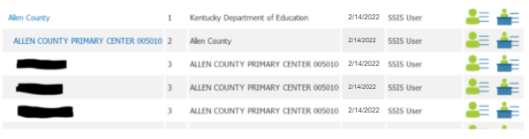
If a class is missing, the district BRIGANCE contact or school OMS administrator should create the class. Directions can be found in Appendix B or on the BRIGANCE OMS Training Site. If a school is missing from the district list, please contact Lisa Jett for support.
Next, check the “User List” in the BRIGANCE OMS. This list shows who has access to the BRIGANCE OMS, and to which role, or level of data management, they have access. Here’s an example of a list of users. Accounts are set up with an email address as the username. The “School/Class” column shows the location the user is assigned. The location varies depending on the role assigned to each user. There are three levels of data management (users):
- Administrators in the BRIGANCE OMS can add and delete users and classes, assign roles, run reports, enter screen data and see screen results for all students at the assigned location. Administrators are usually assigned to a school or district, as illustrated in the example.
- Teachers in the BRIGANCE OMS can run reports, enter screen data and see screen results for all students at the assigned location. Teachers are usually assigned to their class ( the teacher’s name), as illustrated in the example.
- Data Entry users in the BRIGANCE OMS can only enter screen data for students at their assigned location. They are not able to run reports or view screen results. Data Entry users are usually assigned to a class or school.
Example of a User List:
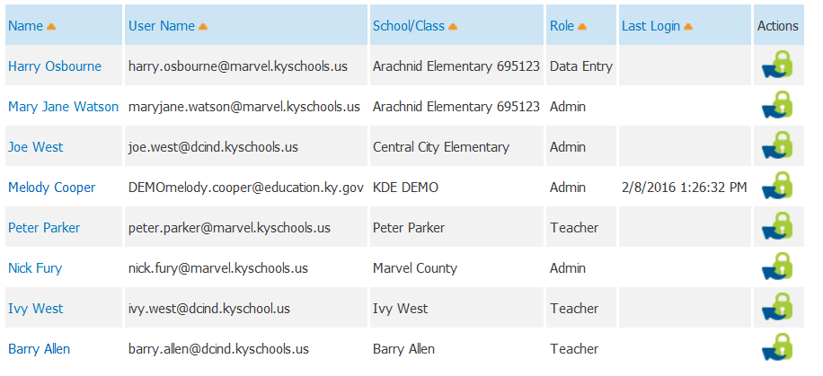
If a user is missing, the district BRIGANCE contact or school BRIGANCE OMS Administrator should add the user. The directions for adding a user can be found in Appendix C or on the BRIGANCE OMS Training Site. If you need a district level account please contact your district BRIGANCE contact to establish your district level account into the OMS. If they have any trouble they can set an account up, contact BRIGANCE Technical Support at (800) 225-0248 ext. 1391 or email OMS Support.
Usernames will contain the district email address of the user with the district or school location ID as an appendix. If the user has a district level role, the appendix will be underscore and your three digit district code. If your role is at the school level the appendix will be underscore and the six digit code.
District level: first.last@district.kyschools.us_012
School level: first.last@district.kyschools.us_012345
The district and school codes can be found in the School Report Card. If you have any difficulties, accessing an account that has been created or setting an account up, contact BRIGANCE Technical Support at (800) 225-0248 ext. 1391 or email OMS Support.

Screening Students
According to 704 KAR 5:070, “Each school district shall administer the common kindergarten entry screen to each student entering kindergarten in the school district no earlier than fifteen (15) calendar days prior to the start of the current academic year and no later than the thirtieth (30th) instructional day of the academic year.”
All staff who administer the screen to students must be trained, as referenced on Page 5 of this guide.
Students must be screened during the district screening window. The window begins 15 calendar days before the first instructional day of school and ends on the 30th instructional day of school. If students do not begin the school year in a district but move in during the screening window, allow one week for the students to populate in the BRIGANCE OMS. If the student appears in the BRIGANCE OMS , the district should screen the child and enter data. If the student does not appear in the BRIGANCE OMS, contact Lisa Jett for support. If the student has screening data entered in another district, he or she will change locations in the BRIGANCE OMS. If a student moves in after the district screening window closes, do not screen the child. If the child appears after the screening window, a district is not required to screen the student.
All new and returning kindergarten students must be screened and screening must be administered in the student’s native language. See Appendix E for guidance regarding English Learners and students with identified delays. Students who have been retained in kindergarten will need to be screened, and they will populate in the BRIGANCE OMS. This data will be included in the final readiness report in the Fall Data Release. Additional information regarding materials, notes on Core Assessments and required portions of the assessments are found in the BRIGANCE K Screen III Examiner’s Manual, see Appendices F-H.
Families must complete the Self-Help and Social-Emotional Scales (Appendix I) during the screening window. Make every effort to obtain the forms from families. If the family has not completed the form, after repeated attempts to obtain it, the teacher may complete the form. Every item must be answered. If an item is left blank, the OMS will not score the Self-Help and Social-Emotional Scales.

Collect Prior Setting Data
State regulation 704 KAR 5:070 mandates that districts collect information regarding a child’s early learning experiences during the year prior to starting kindergarten. Prior settings are defined as:
State-funded preschool: provides preschool services to at-risk 4-year-olds and 3-and 4-year-olds with identified special needs.
Kindergarten: students repeating Kindergarten
Head Start: provides early childhood services to 3-and 4-year-old children who are at-risk.
Childcare: any childcare or private preschool setting licensed by the Division of Regulated Child Care (DRCC). This includes Type 1, Type 2 and Family Certified Homes.
Home: home with a parent/guardian
Other: a family member outside the home (uncle, grandparent, etc.), a private sitter, neighbor or nanny who is not certified, or any other early childhood setting which does not meet the above definitions.
Prior setting data may be collected at any time, so starting early helps ensure data is collected for each student. It is recommended that districts place the prior setting collection form, Appendix D, in kindergarten registration packets. If you are unsure of the location parents noted, follow-up to ensure accuracy.
Prior setting data must be entered in IC. Details can be found in the “Data Entry” section of this guide on Page 10.

Data Entry
Districts must enter Core Assessment and Self-Help/Social-Emotional data into the BRIGANCE OMS during the data entry window. The data entry window begins with the screening window and extends to 15 instructional days beyond the end of the screening window, but no later than October 15. When this date is on a Saturday or Sunday, the final deadline will be on the Monday following the 15th of October. Instructions for entering data into the BRIGANCE OMS are located on the BRIGANCE OMS Training Site. Be sure to view “Part 10: Tips to Avoid Common Pitfalls When Entering Data” before entering student screen data. When entering screen data, districts must use both the “Save” and “Submit” buttons to ensure results are reported.
For the 2022-2023 school year districts should not submit the Self Help and Social Emotional Skills Data (SHSE) in OMS if there is no Core Screen data being input for the student.
Districts must enter prior setting data into IC, on the “Early Learning/Prior Settings” tab. Many students may require more than one prior setting entry. All early learning settings the child attended one year prior to kindergarten should be entered in IC. A new record will be created for each entry. For example, a child who attends state-funded preschool for half the day and stays home with his or her parents the other half of the day should enter two prior settings: state-funded preschool and home. Programs where state-funded preschool and Head Start are blended should mark the students as attending both programs on the prior settings tab in IC.
Prior setting data from parents can be used in conjunction with district records. If documentation supports students who were enrolled in a state-funded preschool program, Head Start program, or are repeating Kindergarten, then data entry staff should enter the prior setting into IC. Since more than one prior setting location is allowable, use district documentation along with information provided by parents. Every effort must be made to obtain prior setting data for each kindergartner. If a facility isn’t an option in IC, please contact Lisa Jett. If no prior setting data can be found after repeated attempts, enter nothing.
Prior setting data does not follow students in IC when they change districts. If a new kindergartner enrolls during the screening window, the “receiving” district must enter prior setting data.
Directions for entering prior settings data in IC can be found in Appendix J or on KDE’s Media Portal.

Checking Data
District BRIGANCE contacts should conduct periodic data checks to ensure everything is entered correctly and in a timely manner. There are two reports in the BRIGANCE OMS to use for checking data entry. Each report should be exported as a CSV file for optimal functionality.
The Group Screening Summary Report lists every student with submitted data, which will be reported to KDE after the Oct. 15 deadline. Use this report to find students with duplicate entries by unchecking the box “Include only the most recent.” When the data is exported as a CSV file, the district BRIGANCE contact can arrange the student names in alphabetical order and check for duplicates. Students should only have one entry. If duplicates appear, delete the duplicate entry in the BRIGANCE OMS. Detailed instructions can be found on the BRIGANCE OMS Training Site, Part 10.
The Screened/Not Screened Report lists every student in the school or district and shows whether the students have data saved but not submitted, or data submitted. This report also shows if students have no screening data entered.
OAA is removing the task of collecting nonparticipation for K Screen Rosters in the Student Data Review and Rosters (SDRR) application. Note: please keep documentation at the school/district level for any student that is not screened.
The Early Learning Prior Settings Report is an ad hoc report in IC, which is most effective when exported as a CSV file. To search for students with no prior setting data, set filters in the spreadsheet and search for blanks in the “Type” field. The students displayed have no prior setting data entered. Please note this report shows every kindergarten student in the district, including those who have been retained. Retained or repeating Kindergarten students MUST include prior setting data. The category “Kindergarten” is now a choice in IC for those students.

Wrapping Up and Next Steps
Checking the district data regularly will aid in the successful completion of the kindergarten screening process. After the data entry window closes statewide, work begins on final state reporting. Notification of kindergarten screening results are sent through District Assessment Coordinator (DAC) email communication. District reporting will likely occur in early December. State level data will be released in the Fall Data Release. DACs receive links to district readiness files with individual student data and prior setting readiness reports. The state report is available in the school and district School Report Card. If assistance is needed concerning the K Screen process please contact Lisa Jett. If you need technical assistance with the OMS website please contact BRIGANCE Technical Support at (800) 225-0248 ext. 1391 or email OMS Support.

Appendix A – Implementation Agreement
Implementation of Kentucky’s Kindergarten Entry Screener: 704 KAR 5:070

Staff with any of the following responsibilities must agree to abide by the requirements set forth in 704 KAR 5:070:
- Administering screen;
- Entering screen data; and/or
- Using screen data at the classroom, building or district level.

- Use the screening tool adopted by Kentucky, the BRIGANCE K Screen.
  - Approved trainers prepare staff to administer the BRIGANCE K Screen.
  - Administer and use the results of the BRIGANCE K Screen with fidelity.

- Screen within the time frame, as set forth in 704 KAR 5:070:
  - no more than 15 calendar days prior to the start of school
  - no later than the 30th instructional day

- Input all screen data into the Online Management System (OMS) within 15 instructional days after the 30th instructional day and no later than Oct. 15. When this date is on a Saturday or Sunday, the final deadline will be on the Monday following Oct. 15.

- Provide parents or guardians with screen results.

- Enroll all children who meet the requirements set forth in KRS 159:010 (are 5 on or before Aug. 1), regardless of screen outcomes.

- Use the kindergarten entry screen data as a system of measurement, as outlined in 704 KAR 5:070:
  - to inform districts, parents and communities about early learning in order to close the school readiness gap
  - to make informed policy decisions at the local level to support early learning experiences prior to school entry
  - to establish local goals for program improvement in order to achieve early learning outcomes
  - to include data as evidences in the kindergarten through 3rd grade Program Evaluation under 703 KAR 5:230
  - The results of the kindergarten entry screen may not be utilized as part of the school’s or district’s overall score to determine recognition in any administrative regulation promulgated by the Kentucky Board of Education, pursuant to KRS 158.6455.

District______________________________________ School___________________________________
I have received, read and will comply with the implementation of Kentucky’s Kindergarten Entry Screen 704 KAR 5:070

Signature Date

Appendix B – Creating a Class in the BRIGANCE OMS
Select “School/Class List” from the account tab:
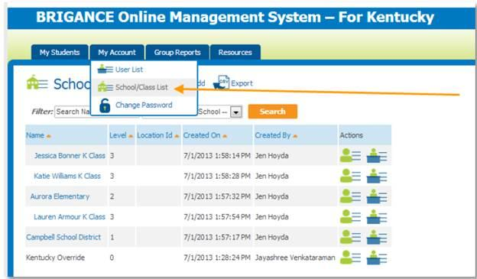

Click the “Add” button:
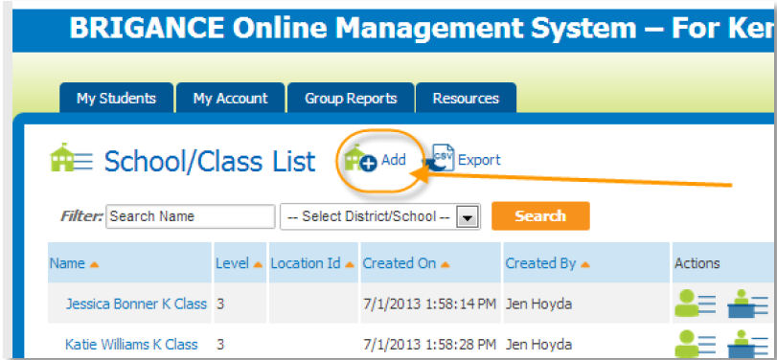

Fill in each box. The “Name” should be the teacher’s first and last name; for “Parent District/School” select the name of the school from the drop-down menu; the “School/Class ID” MUST be the teacher’s district email address. Click submit.
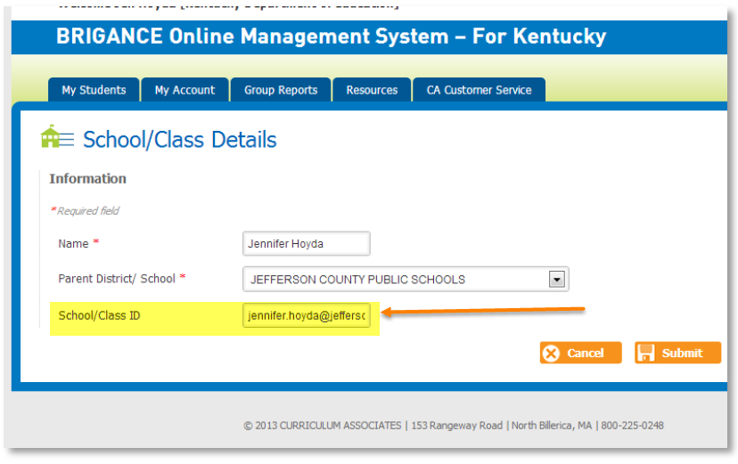

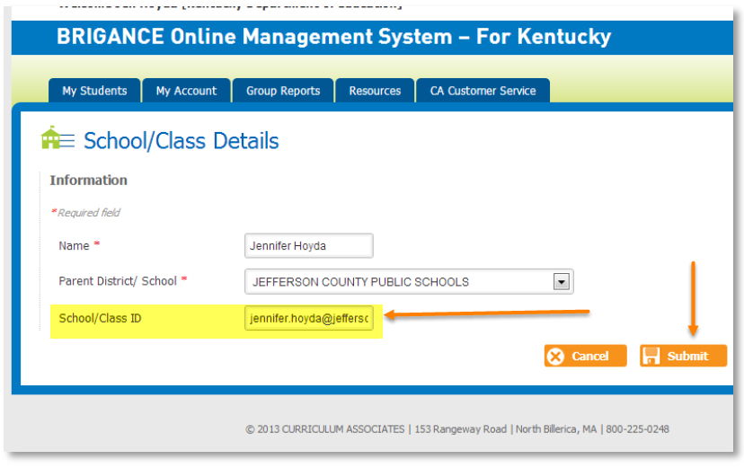
Assigning a teacher to his or her class
Select “User List” from the account tab:

Click the teacher’s name, which should be in the system:
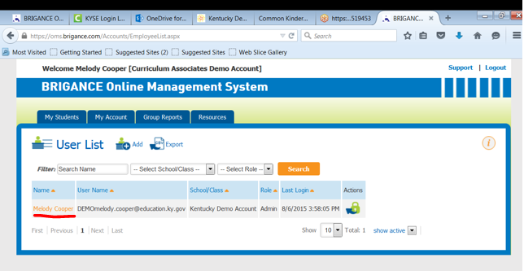
If the teacher is not in the user list, click “Add” from the user list. Fill out all the required boxes and use the teacher email address for the user name.
In the School/Class drop-down menu, select the name of the class you created (the teacher’s first and last name). Click save. If the system shows an error message regarding the password requirements, change the password to something generic (must include an uppercase letter and a number). The teacher may change the password if desired. On your screen, you have the option to save and send an email notification and you may click that as well.
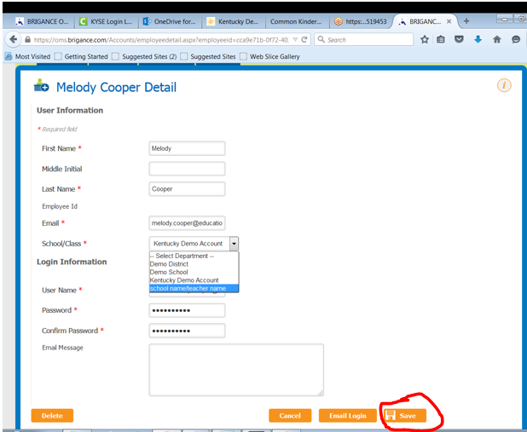

Appendix C – Adding a User in the BRIGANCE OMS
Select “User List” from the account tab:
From the User List, click “Add”:
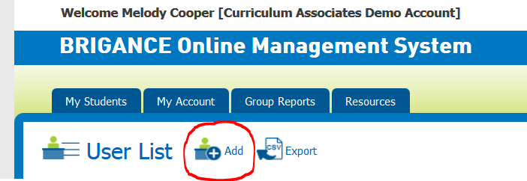

Fill in the required fields. The school/class box assigns the user to a location. The location assignment is related to the role assignment (administrator, teacher or data entry). Please refer to the section on “Setting Up Users in the OMS,” found on Pages 7-9. Don’t forget to click “Save and Email Login.”
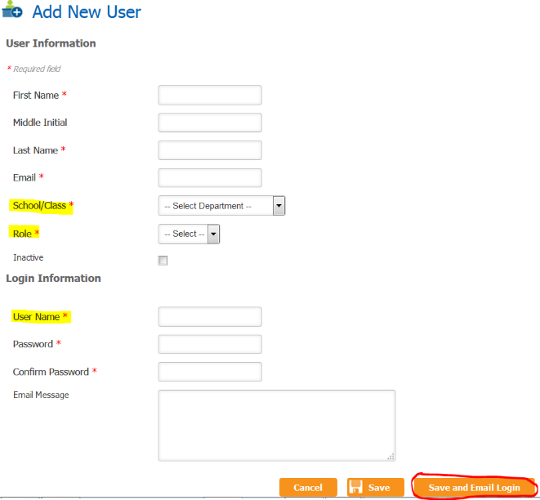
*Usernames must have appendices. Please refer to pages 7-9 “Setting up Users in the BRIGANCE OMS”.

Appendix D – Prior Setting Form
Kindergarten Prior Setting Data
Dear Parent/Guardian;

School readiness for all children is critical to the success of students. Through an initiative begun by then-Gov. Steve Beshear in 2010, Kentucky is focused on ensuring that all young children who enter kindergarten are ready to grow, ready to learn and ready to succeed. One way that our district can support our families, stakeholders and community partners with promoting school readiness is by learning more about the early care settings our children have experienced before they enter school.

Our district is required, as part of 704 KAR 5:070, to collect information about where your child received early care services for the 12 months prior to coming to kindergarten. There are five basic categories that children may receive care before entering kindergarten:

State-funded preschool: Children who attend the state-funded preschool program, which, as defined in 704 KAR 3:410, provides preschool services to at-risk 4-year-olds and 3- and 4-year-olds with identified special needs.

Head Start: Children who attend Head Start, which provides early childhood services to 3- and 4-year-old children who are at risk.

Childcare: Children who attend any childcare or private preschool setting that is licensed by the Division of Regulated Child Care. This includes Type 1, Type 2 and Family Certified Homes.

Home: A child who is at home with a parent/guardian before entering school.

Other: A child received care from one of the following:
- a family member, such as a grandparent, aunt, uncle, sibling
- a private sitter, who is not certified, such as a neighbor, nanny or other
- other early childhood setting that does not meet the above definitions

On the attached form, please provide the following information in the fields that are applicable to your child’s previous 12 months. There may only be one prior setting your child participated in, or there may be multiple settings. If you need more space than is provided for any category, please provide the information on the back of the document.

- Child’s name: last, middle initial, first name
- Child’s date of birth (month, day, year)
- Child’s street address, including city, state, zip code
- Prior Setting Information: Where has the child received early care services within the last 12 months? You may choose more than one option, if necessary. For example, your child may have had a change in care within the last 12 months. You would also need to choose more than one setting if your child attended a half-day program, then spent the other half-day at a childcare facility, babysitter or at home. If your child was in kindergarten last year and is a repeating kindergartener this year, select Kindergarten.

If you have questions about prior setting information, please ask your child’s teacher or office manager for clarification. We look forward to working with your family to ensure your child’s success throughout kindergarten and beyond.

Sincerely,
District/School Staff

Kindergarten Enrollment Prior Setting Data
Name: _____________________________________________ _____________________ Date of Birth: ________________________________________

Address: ______________________________________________________________________________________________________________________
Please provide information about every early care setting your child attended during the year prior to kindergarten. Fill out a new box for each location.
Setting 1:

State-funded preschool Head Start Child Care Home Other (circle one)

Facility/School Name: _______________________________________________________________________________________________

Address: _______________________________________________________________________________________________

Start Date: ______________ End Date: _______________

Setting 2:

State-funded preschool Head Start Child Care Home Other (circle one)

Facility/School Name: _______________________________________________________________________________________________

Address: _______________________________________________________________________________________________

Start Date: ______________ End Date: _______________

Setting 3:

State-funded preschool Head Start Child Care Home Other (circle one)

Facility/School Name: _______________________________________________________________________________________________

Address: _______________________________________________________________________________________________

Start Date: ______________ End Date: _______________

Setting 4:

State-funded preschool Head Start Child Care Home Other (circle one)

Facility/School Name: _______________________________________________________________________________________________

Address: _______________________________________________________________________________________________

Start Date: ______________ End Date: _______________

Setting 5:

State-funded preschool Head Start Child Care Home Other (circle one)

Facility/School Name: _______________________________________________________________________________________________

Address: _______________________________________________________________________________________________

Start Date: ______________ End Date: _______________

Información Educativa Previa a Kindergarten
Otoño ____
Estimados padres / tutores;
La preparación previa de todos los niños a la escuela es fundamental para su posterior éxito. El estado de Kentucky se centra en garantizar que todos los niños pequeños que comiencen Kindergarten, estén listos para crecer, dispuestos a aprender, y preparados para tener éxito a lo largo de su vida. Una forma en la que nuestro distrito puede ayudar a nuestras familias, grupos de interés y socios comunitarios en promover esta preparación escolar, es saber más acerca de dónde vienen nuestros niños, antes de que empiecen Kindergarten en la escuela.
Como parte de la regulación 704 KAR 5: 070, nuestro distrito debe recopilar información acerca de donde su hijo cursó preescolar durante los 12 meses previos a su ingreso en Kindergarten. Hay cinco categorías de centros de preescolar en los que los niños pueden haber recibido este tipo de servicios antes de comenzar Kindergarten:
Centros de Preescolar Financiados por el Estado: Se considera en esta categoría a los niños que atienden estos programas de preescolar financiados por el estado, que, de acuerdo a la regulación 704 KAR 3: 410, proporcionan servicios de preescolar a niños de 4 años en situación de riesgo, y niños de 3 y 4 años con necesidades especiales identificadas.
Head Start: Se considera en esta categoría a los niños que atienden este tipo de centro, que ofrece servicio de preescolar a niños de 3 y 4 años en situación de riesgo.
Guardería: Se considera en esta categoría a los niños que atienden a cualquier guardería o centro privado de preescolar que esté autorizado por la División de Cuidado Infantil Regulado (DRCC). Se incluye en esta categoría centros de tipo 1, tipo 2 y Hogares Certificados para Familias.
En casa: Se considera en esta categoría a los niños que están en casa con los padres / tutores antes de comenzar la escuela.
Otros: Se considera en esta categoría a los niños que están al cuidado de alguna de las siguientes personas:
- un miembro de la familia, como un abuelo, una abuela, un tío, una tía, un hermano o una hermana
- una cuidadora privada, no acreditada (sin certificación), como un vecino, una niñera u otra persona
- cualquier otra categoría de centro de preescolar o persona que proporciona de servicios de preescolar que no cumple con los requisitos mencionados anteriormente.

En el formulario que se adjunta, por favor proporcione la información que sea necesaria y relativa a los 12 meses previos al ingreso de su hijo en Kindergarten. Puede que su hijo esté dentro de una o varias de las categorías antes mencionadas. Si necesita más espacio del que se le proporciona, por favor escriba la información en el reverso del documento.
1. Nombre del Niño: Apellido, inicial del nombre medio, nombre,
2. Fecha de nacimiento del niño (mes, día, año)
3. Dirección postal del niño, incluyendo ciudad, estado, código postal
4. Información Educativa Previa a Kindergarten: ¿Dónde ha cursado o recibido los servicios de preescolar en los últimos 12 meses? Usted puede elegir más de una opción, si es necesario. Por ejemplo, su hijo puede cambiado de centro o de lugar donde ha recibido estos servicios de preescolar en los últimos 12 meses. Usted también tendría que elegir más de una opción si el niño atendió a un programa una mitad del día (por ejemplo, por la mañana), y luego pasó la otra mitad (por ejemplo, por la tarde) en unas instalaciones para el cuidado de niños, o con una niñera, o en casa. Si su hijo estuvo en el jardín de infantes el año pasado y es un kínder repetido este año, seleccione Kindergarten.
Si tiene alguna pregunta acerca de la Información Educativa Previa a Kindergarten, por favor pregunte al maestro de su hijo o diríjase a la oficina del centro al que su hijo acude para pedir información. Esperamos poder seguir trabajando con su familia para asegurar que su hijo cumpla con éxito su año kindergarten y los posteriores.
Atentamente,
Distrito / Personal de la Escuela
Datos sobre Educación Previa al Registro en Kindergarten

Nombre: ______________________________________Fecha de Nacimiento:____________________________________
Dirección: ___________________________________________________________________________________________________

Por favor, proporcione información sobre todos los tipos de centros de preescolar a los que su hijo asistió durante el año previo a Kindergarten. Rellene una casilla por cada centro.
Tipo de Centro de Preescolar 1:

Centro de Preescolar financiado por el estado Head Start Guardería Casa Otro (seleccione una de las categorías con un círculo)

Instalación / nombre de la escuela: _______________________________________________________________________________________________

dirección : _____________________________________________________________________________________________________________________

echa de inicio : ______________ fecha de finalización : _______________

Tipo de Centro de Preescolar 2:

Centro de Preescolar financiado por el estado Head Start Guardería Casa Otro (seleccione una de las categorías con un círculo)

Instalación / nombre de la escuela: _______________________________________________________________________________________________

dirección : ______________________________________________________________________________________________________________________

echa de inicio : ______________ fecha de finalización : _______________

Tipo de Centro de Preescolar 3:

Centro de Preescolar financiado por el estado Head Start Guardería Casa Otro (seleccione una de las categorías con un círculo)

Instalación / nombre de la escuela: _______________________________________________________________________________________________

dirección : _____________________________________________________________________________________________________________________

echa de inicio : ______________ fecha de finalización : _______________

Tipo de Centro de Preescolar 4:

Centro de Preescolar financiado por el estado Head Start Guardería Casa Otro (seleccione una de las categorías con un círculo)

Instalación / nombre de la escuela: _______________________________________________________________________________________________

dirección : ______________________________________________________________________________________________________________________

echa de inicio : ______________ fecha de finalización : _______________

Tipo de Centro de Preescolar 5:

Centro de Preescolar financiado por el estado Head Start Guardería Casa Otro (seleccione una de las categorías con un círculo)

Instalación / nombre de la escuela: _______________________________________________________________________________________________

dirección : _____________________________________________________________________________________________________________________

echa de inicio : ______________ fecha de finalización : _______________

Appendix E – Additional Guidance for English Learners and Special Needs Students
Kentucky requires every student entering kindergarten be screened using the common kindergarten screen, the BRIGANCE K Screen III. Please review this guidance for screening English Learners and children with special needs to ensure valid screen administration for all students. This guidance is reflective of the BRIGANCE K Screen III (reference introduction Page xxiv and xxv of the Screen manual).
English Learners (ELs)
The purpose of conducting the BRIGANCE Screen III is to measure a child’s readiness as he or she enters school. The purpose is not to identify whether a student may be an English Learner or to determine the child’s level of English language proficiency. Kentucky uses the ACCESS for ELL® assessment to measure English acquisition and proficiency.
The BRIGANCE K Screen is not a paper-pencil test that requires translation and printing. The intent, as described on Page xxvi of the BRIGANCE K-1 Screen Manual is for children to be screened in their native language, using a professional interpreter. With the support of Curriculum Associates, KDE has clarified the definition of professional interpreter. The intent is the interpreter has experience to translate as literally as possible. It is critical that the interpreter is competent in both English and the language being interpreted so that he or she can communicate the responses of the student to the screen administrators.
Suggestions for finding interpreters:
- Utilize bilingual personnel in your building or district
- Seek volunteer interpreters (e.g., corporate volunteers or volunteers from a local university, college or community college)
- Utilize a friend of the family (i.e., if this person has been trained in asking questions and does not lead the child for the responses)
A student entering kindergarten may not be identified as an English Learner at the time of the BRIGANCE K Screen III administration. District and school staff must use best judgment in determining if the students are screened in English or another language. There are cases in which the Core Assessments may be given in one language while the Self-Help and Social Emotional Scale is provided to a parent/guardian in another language to meet the individual needs of the family.
Children with Special Needs
As described on introductory Page xxiv of the “BRIGANCE K&1 Screen III Manual”, accommodations may be necessary when screening children with special considerations. It is important for administrators to recognize the difference between accommodations and modifications and how to use accommodations appropriately when administering assessments. This is crucial in standardized screening, as results could be invalidated if correct procedures are not in place.
Accommodations are alterations for administering the assessments which enable children to more accurately demonstrate their knowledge. Some examples of acceptable accommodations are allowing extended response time, using a magnifying glass for students with visual impairments and covering partial sections which appear too “busy” on the page for some students.
Modifications, comparatively, are changes to the actual content of the assessment (for instance, changing the phrasing of a question). Modifications may not be used under any circumstance, as this will invalidate the standardized data.
Carefully read the guidance on introductory Page xxiv of the “BRIGANCE K Screen III Manual” for specific details and guidance for children with special needs including motor impairment, severe speech impairment, autism spectrum disorders and potential giftedness.

Appendix F – Screening Materials
BRIGANCE Kindergarten Screen III Kit:
K & 1 Screen III Examiner’s Manual – Schools receive ONE manual for every kindergarten class (most classrooms have a manual). The manual comes with colored objects for sorting and counting.
Data Sheets – one carbonless triplicate form per child
Technical Report for the Screen III – Contains scoring information as well as in-depth research on the reliability, validity and accuracy of the screening tool.
Additional Items Needed:
Ink pen to record data
Unlined 8½” x 11” sheets of paper
Lined paper – any type used instructionally in the kindergarten classroom
Pencils – any type used instructionally in the kindergarten classroom
A timer or watch with a second hand
Picture books with at least three lines of text per page
Photocopies made from Examiner’s Manual – Parent’s Report of the Self-Help and Social-Emotional Scale (electronic PDF available from district BRIGANCE contacts), Teacher’s Report of the Self-Help and Social-Emotional Scales (only if unable to obtain from parents), Reading Readiness Scale scoring form (optional), Supplemental Assessments Data Sheet (optional for students who perform well on Core Assessments)
BRIGANCE OMS
Teacher log-in information – to login for the first time each year, visit the BRIGANCE OMS Login page, enter district email address and click “Forgot Password.” An email containing login credentials should arrive almost immediately, though the message is sometimes delivered to the “Junk” or “Clutter'' folders. Once logged in, passwords should be changed to something personal and secure. Do not share login credentials with others, as the BRIGANCE OMS contains personal identifiable information. (Each staff member must have his or her own user account.) The 2022-2023 BRIGANCE OMS account will be active in early August. As a reminder logins now require the use of appendices in the user name please refer to page 8 for an example of this.

Appendix G – Notes on Kindergarten Core Assessments
Additional Notes on administration: thoroughly read the directions and criteria for each assessment; re-screening is not allowed.
1A  Personal Data Response | Name  Acceptable responses: legal name or given name such as Katherine  Nicknames, like Katie for Katherine, are allowed if this is primarily how the child is known.  No credit: if the child provides a nickname that is really a ‘pet name’ like ‘buddy’ or ‘ladybug’ or if the child provides just a first initial like K for Katie  Phone number  Acceptable responses: correct phone number of a responsible adult (home phone, parent cell phone – it could be a caregiver’s or neighbor’s phone if there is no phone and that’s the number used by the family)  No credit: if the child does not know any number for reaching a responsible adult/parent/caregiver  Address Acceptable Responses  Number and street name (if there is a number and street name), no city or zip required  General description of area (IF no number and street name), rural route
2A  Names the Parts of the Body | Screen administrator should point to his/her own body.
3A  Gross Motor Skills | It is okay to demonstrate the skill for the child.
4A  Visual Motor Skills | Best practice: photocopy the student page or put paper under/below the shapes on the page (not next to them).
5A  Prints Personal Information | Tip: direct child to print his/her name on sheet they used for shapes
6A  Recites Alphabet | Child should recite, not sing, the alphabet
7A  Sorts Objects | Item #1: say “large” and not “big” when giving directions.
8A  Counts by Rote | There are additional directions for eliciting a response if the child does not respond to the initial question.
9A  Matches Quantities with Numerals | Tip: use objects - fingers can be tricky for the children to maneuver
10A  Determines Total of Two Sets | You may cover the other pictures if a child has difficulty focusing on one domino at a time.
11A  Reads Uppercase Letters | Important: Kentucky requires that everyone must administer Reads UPPERCASE Letters.  It is okay to use 11A Alternate, Reads Lowercase Letters in addition, but do not score on the Data Sheet and do not enter in the OMS.
12A  Experience with Books and Text | The picture book must have at least 3 lines of text on each page.  Tip: have more than one book handy that appeals to children, and ask the child which they’d like to read
13A  Verbal Fluency & Articulation | This subtest is administered through observation during the prior parts of the screening and should not require student questioning. However, if the student has been very quiet, the screener can use one of the books from 12A to elicit more verbal response.

Appendix H – Requirements and Recommendations
Requirement | BRIGANCE® K Screen Tool or Resource | What to do with the Data Sheet(s) or Information | Timeline/Deadlines | Additional Notes, Requirements and Guidelines
REQUIRED | K Core Assessments | Copy 1 Student File  Copy 2 Teacher File  Copy 3 District Decision  **If a tablet or iPad is used for collecting the responses instead of the data sheets, please print a copy of the Online Data Sheet for the student and district files. | Screening takes place no sooner than 15 days prior to the start of school and no later than the 30th day of instruction.  All data must be entered in the OMS and IC by the 15th instructional day after the screening window closes AND no later than October 15.  For children who enroll after the 30th day of instruction: if screen data is not available from the previous school, the school may administer the screen, but the data will not be included in reporting. | Use the Spanish Directions to administer the screen to Spanish-speaking students.  For children whose primary language is not English or Spanish, districts will use resources at the district level, such as interpreters, to gather data.  For children with exceptionalities, follow the guidelines in the Introduction section of the BRIGANCE® Kindergarten Screen.  Enter data into the BRIGANCE® OMS and review the Screening Summary Report. If the child scores below the “Ready” cutoff, consider initiating the RTI process, if additional data supports that decision.
REQUIRED | Self-Help and Social Emotional Scales | Student Files | See above. | Give the parent 2-3 weeks to complete the Parent Form. If the parent does not submit the form, complete the Teacher Form.  Use the Spanish version for Spanish-speaking families.
REQUIRED | Online Management System | Core Assessment - Enter what is recorded on the data sheets, including notes, into the OMS.  Self-Help and Social-Emotional Scales – enter what the family reports into the OMS. | All data must be entered in the OMS and IC by the 15th instructional day after the screening window closes AND no later than October 15. | Data will merge between IC and the OMS on a weekly basis.
Strongly Recommended | Supplemental Assessments | Student Files  No need to report to KDE | N/A | Supplemental Assessments can provide additional information for instructional planning and are recommended for students who perform well on the Core Assessments.
Strongly Recommended | Reading Readiness Scale | Student Files  No need to report to KDE | N/A | The Reading Readiness Scale will provide teachers with additional information with which to plan instruction.
Optional | Rating Forms (Teacher, Parent) | N/A | N/A
Do not Use | Hearing and Vision Observations | N/A | N/A
Recommended | Observations | District decision: Classroom teacher enters Observations | N/A | Enter anecdotal notes and observations into the OMS for each student, selecting the appropriate domain category.
Recommended | Readiness Activities | District decision: Classroom teacher uses Readiness Activities | N/A | Using the results of the Basic Assessments and Social and Emotional Scales, incorporate the appropriate Readiness Activities into classroom instruction to help develop key skills.
Recommended | Family Connections | District decision: Classroom teacher uses Family Connections resources | N/A | Use the applicable letters and reports to share information with families and build family-school connections.
Optional | Observations | District decision: Classroom teacher enters Observations | N/A | Enter anecdotal notes and observations into the OMS for each student, selecting the appropriate domain category.

Appendix I – Self-Help and Social-Emotional Scales
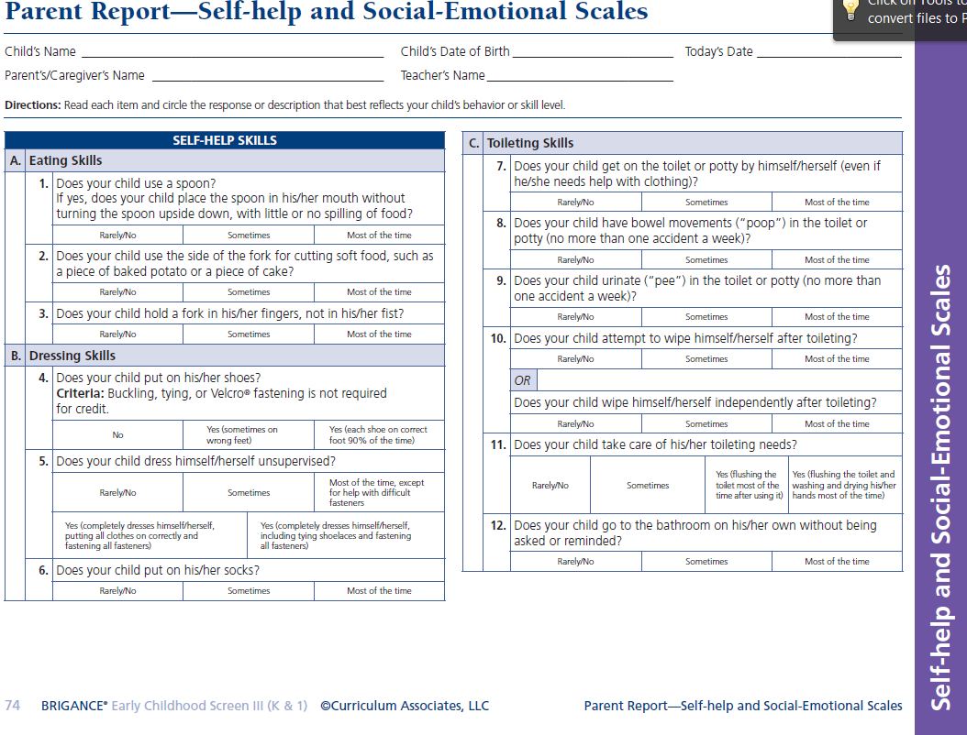
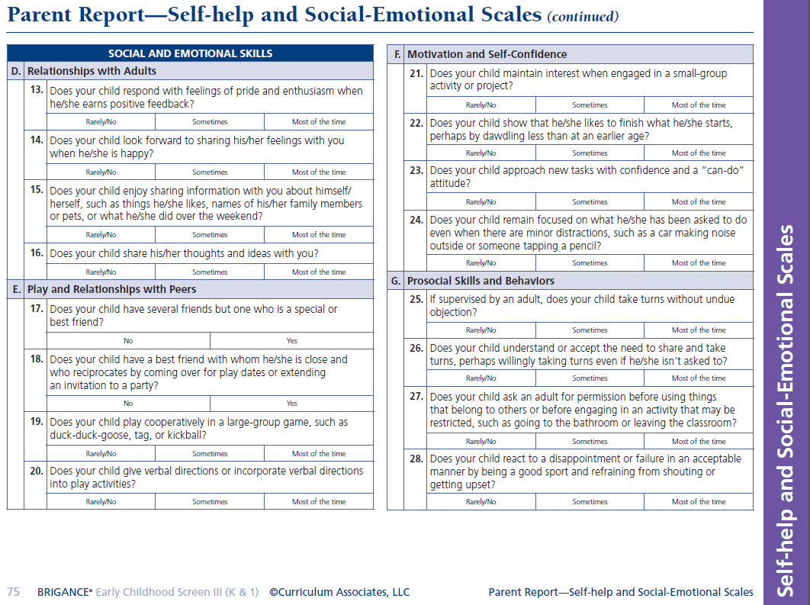
Note: this copy is only for reference. For screening purposes, duplicate the full-page version from the Examiner’s Manual or obtain electronic PDF copies from the district BRIGANCE contact or K Screen website.
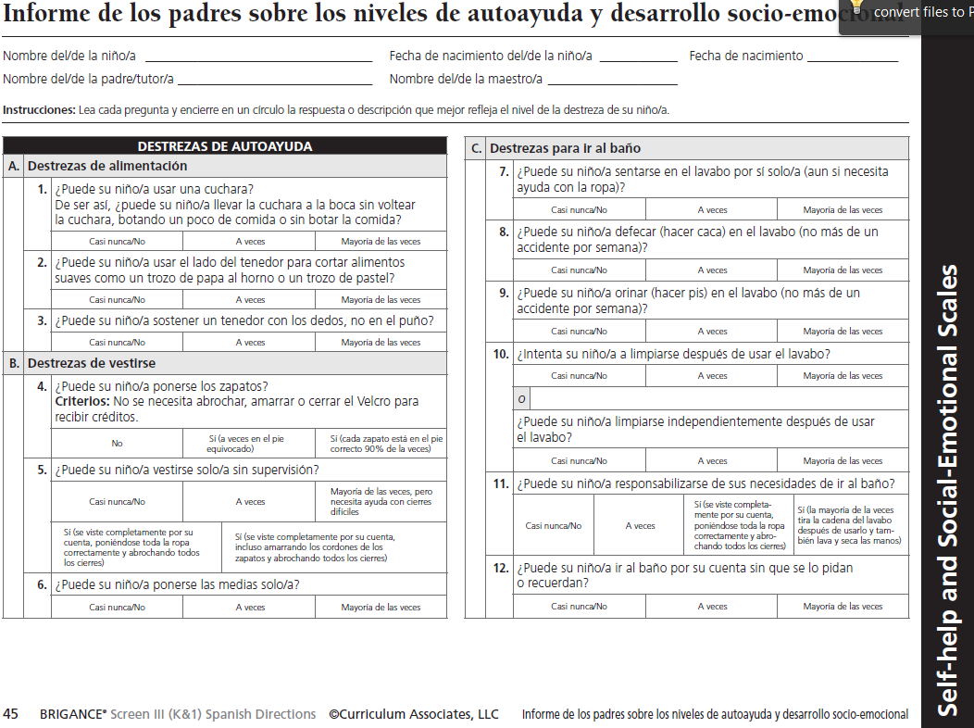

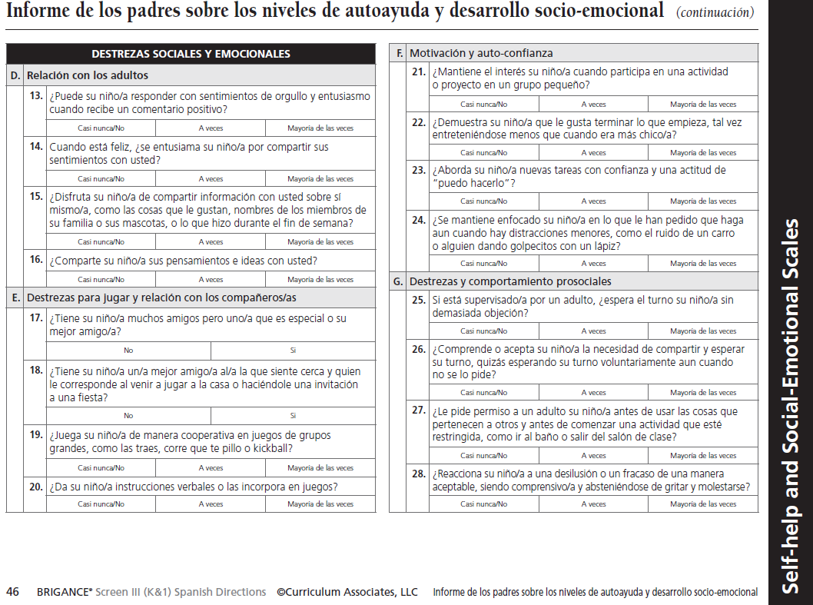
Note: this copy is only for reference. For screening purposes, duplicate the full-page version from the Examiner’s Manual or obtain electronic PDF copies from the district BRIGANCE contact or K Screen website.

Appendix J – Directions for Entering Prior Setting Data
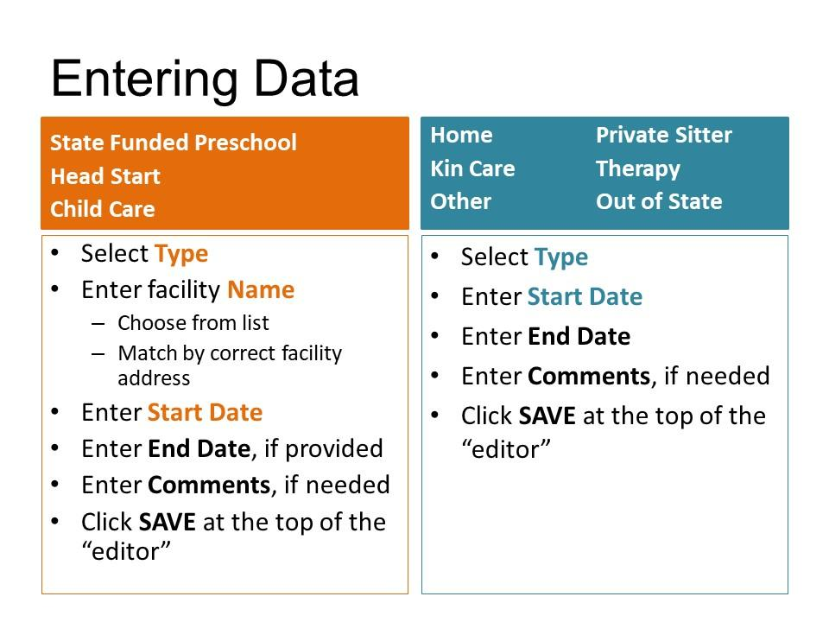

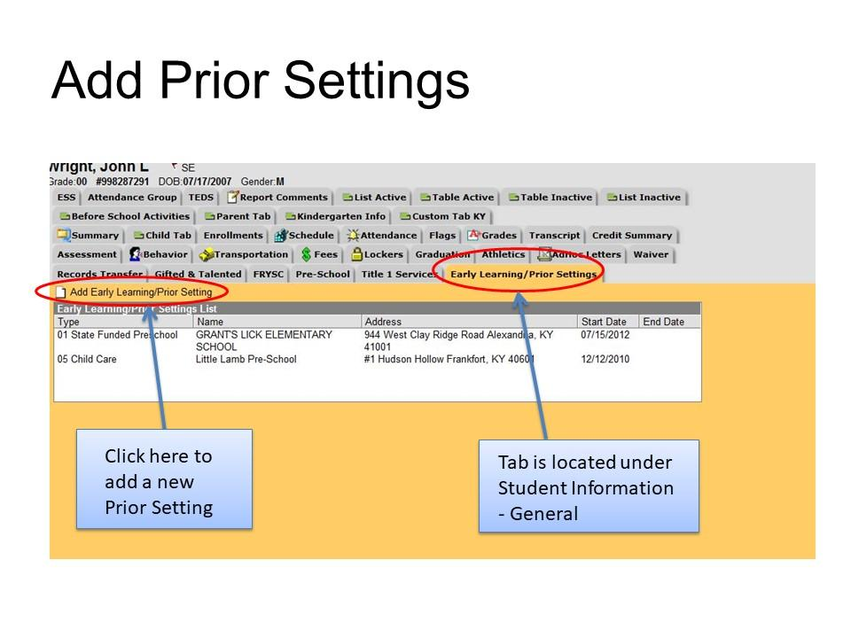
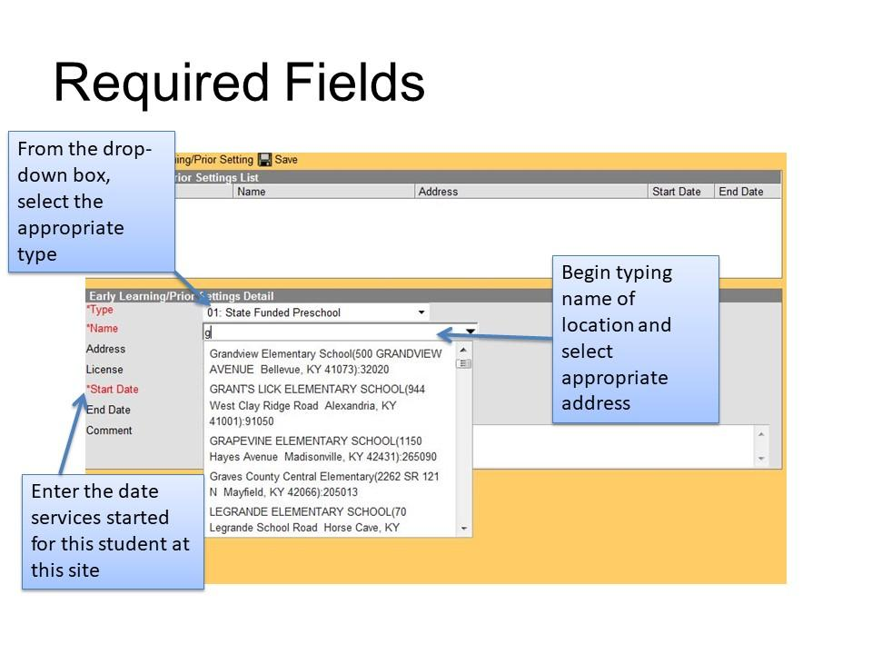

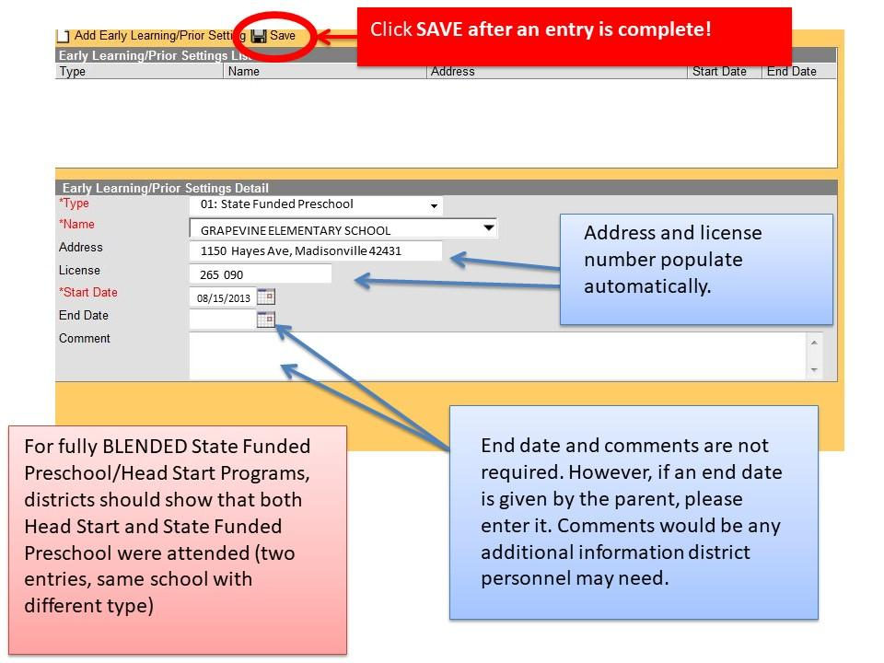
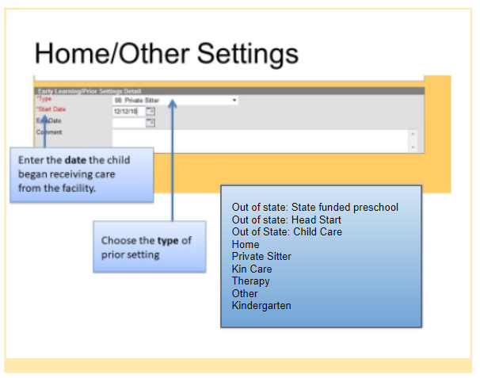

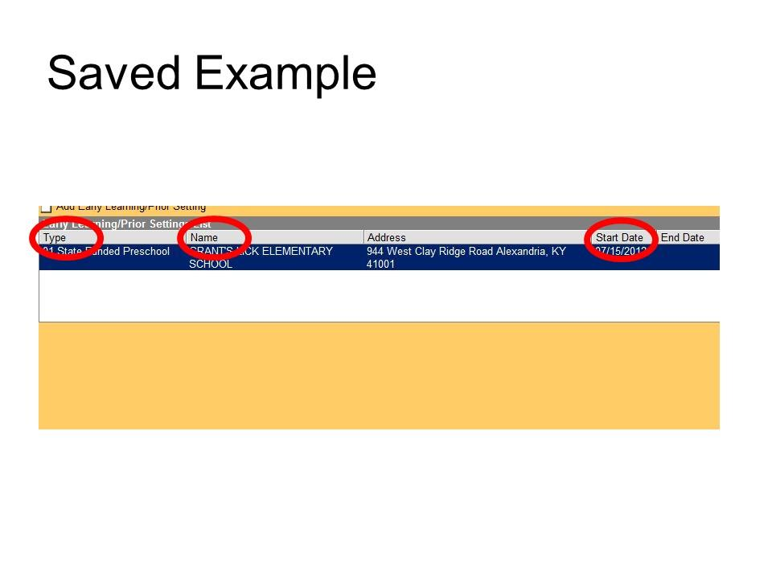

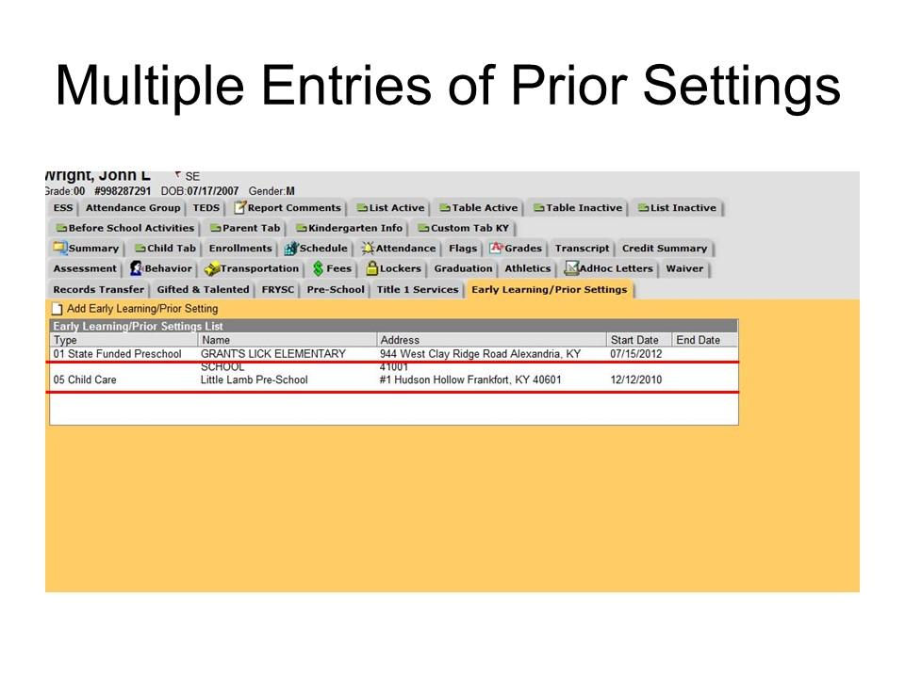
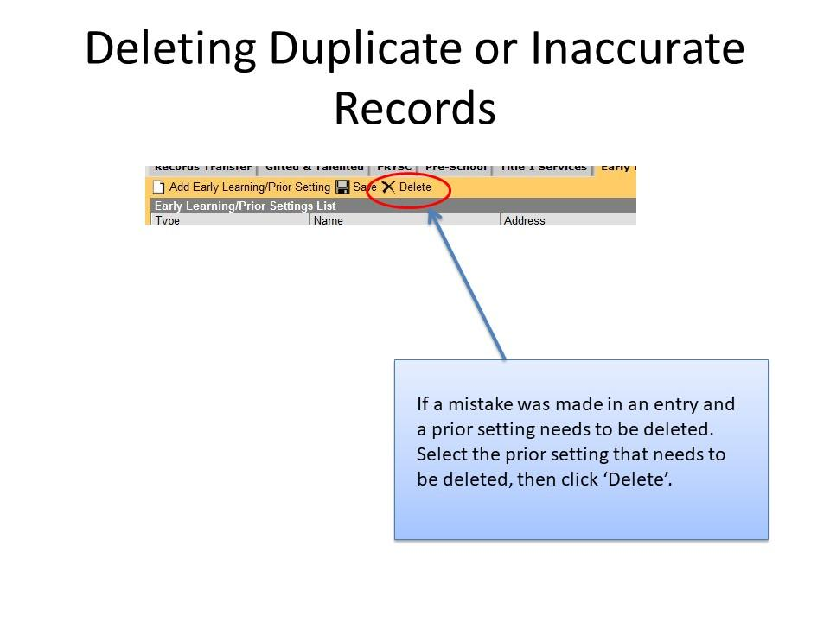

Appendix K – Key Dates and Timelines for the 2022-2023 School Year
All trainings will be virtual for the 2022-2023 School Year
March 7 – April 1 – K Screen materials ordering window

March 18 – TOT refresher webcast available for district trainers who have previously attended a TOT

March 25 -- Training of Trainers (TOT) sessions for NEW district trainers

Late May 2021 – Screen materials shipped to each school

July 1 – staff files for BRIGANCE OMS to Lisa Jett
- Instructions and template to be distributed in April
- District K Screen contact responsible for this

July 22 – Training of Trainers (TOT) session for NEW district trainers

June-Aug. – Staff Training on the BRIGANCE K Screen III
- Specific timing TBD by each district

June-Aug. – Training on the BRIGANCE OMS
- BRIGANCE OMS Training Site
- Mandatory for staff who are new to administering the screen and for those entering data into the system

Mid-July through Sept. – Screen windows open (based on individual school calendars)
- Note the regulatory screen window is no earlier than 15 days prior to the first day of school and no later than the 30th instructional day.
Mid-Aug. – BRIGANCE OMS account ready
- Use your district email address and the “forgot password” feature to login.
- If you are unable to login because you do not have an account created, ask your building or district K Screen contact to add you into the system. Please ensure that you are using the login appendices with your username. Please see page 8 for more information.

Sept.-Oct. – Data entry into the BRIGANCE OMS
- Districts have up to 15 instructional days after the 30th instructional day to enter data into the BRIGANCE OMS, with all data entered by October 15.

Oct. 15 – Deadline for entering student data in BRIGANCE OMS

Dec. – District Reporting
- State level report is released in the Supplemental Data section of KDE’s Open House
- DACs receive student level reports via DAC email messages. State Reporting will occur with the following Fall Data Release.

Appendix L – K Screen Task Management Checklist
_____Read all K Screen Updates for deadlines and important information
Distribute to building principals
_____Order screening materials
_____Attend training
_____Identify district screening window
_____Train district and school staff
_____Assign roles and responsibilities
Determine who will screen students
Determine who will enter data
_____Set up classes in Infinite Campus (IC)
_____Submit Staff File for the BRIGANCE Online Management System (OMS)
_____Check BRIGANCE OMS for correct users, schools and classes
_____Collect prior setting information from parents
_____Administer the BRIGANCE K Screen III during the district’s screening window
Core assessments administered by trained staff
Self-Help and Social-Emotional Scales completed by parents and returned to school
_____Enter data into BRIGANCE OMS and IC
Core assessments and Self-Help and Social-Emotional Scales into the BRIGANCE OMS
Prior settings into IC
_____Complete periodic data checks during your screening and data entry window
Reports in the BRIGANCE OMS
Ad hoc reports in IC
_____Determine next steps based on district data

Appendix M -- Infinite Campus K Screen Reference Guide
- To help avoid possible conflicts with SSIDs, the Student Locator should always be used when enrolling kindergarten students.

- From the Index [1], navigate to Student Information [2] and select Student Locator [3]. Enter at least three search criteria [4] and click Search [5].

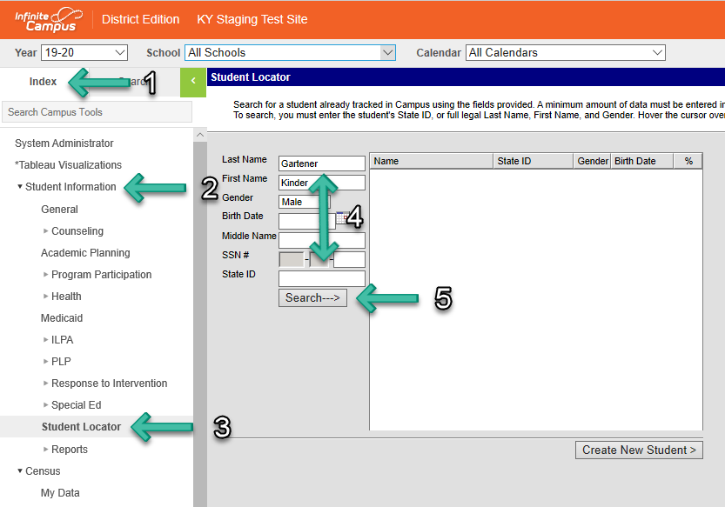

- Check any possible matches which may appear to determine if the kindergartener already has a past or present enrollment within a KY public school. Click the appropriate match if available to select the kindergartener and retain the existing SSID [6a].

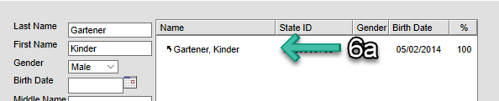

- If no matches are found [6b], click Create New Student [7].

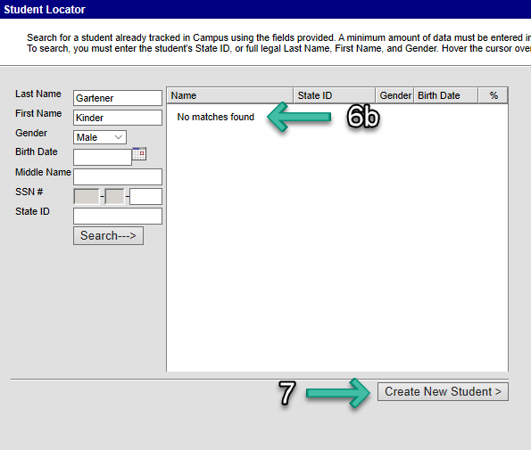

- Ensure suffixes have been correctly entered into Campus, if applicable.

- From the Index [1], navigate to Census [2] and select People [3]. On the Demographics tab [4], scroll down to the Person Information section [5] and verify the suffix has not been entered into the Last Name field [6].

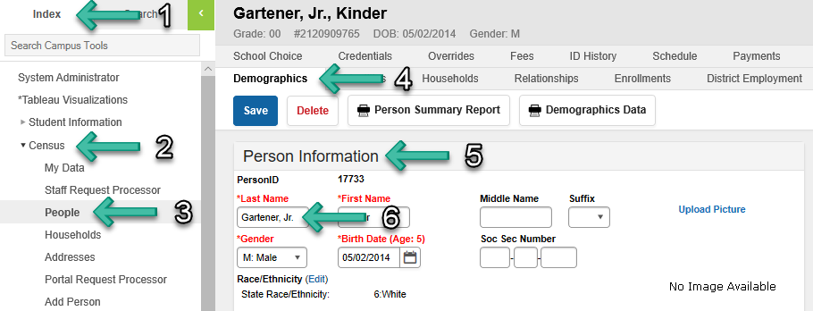

- Suffixes should only be entered into the Suffix field [7].

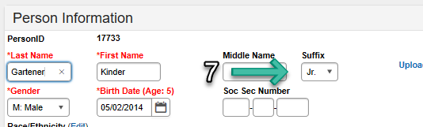

- Ensure kindergartners’ birth dates have been entered correctly.

- From the Index [1], navigate to Census [2] and select People [3]. On the Demographics tab [4], scroll down to the Person Information section [5] and verify the correct date has been entered into the Birth Date field [6].

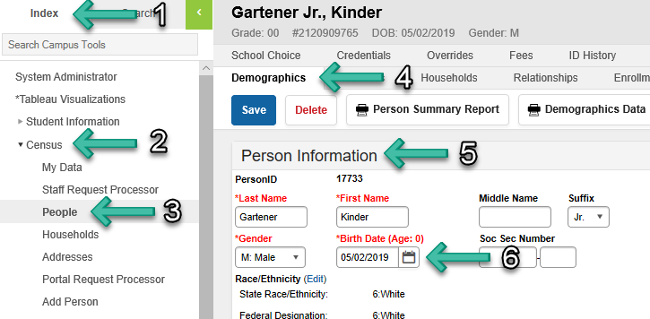

- If the correct birth date has been entered, the kindergartener’s correct age should be displayed.

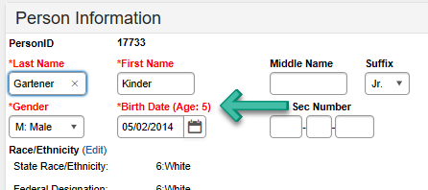

- Ensure the kindergartener’s enrollment has not been marked as State Exclude.

- From the Index [1], navigate to Student Information [2] and select General [3]. Click the Enrollments tab [4] and select the kindergartener’s current enrollment [5]. Ensure the enrollment type is P and the student is enrolled in grade 00.

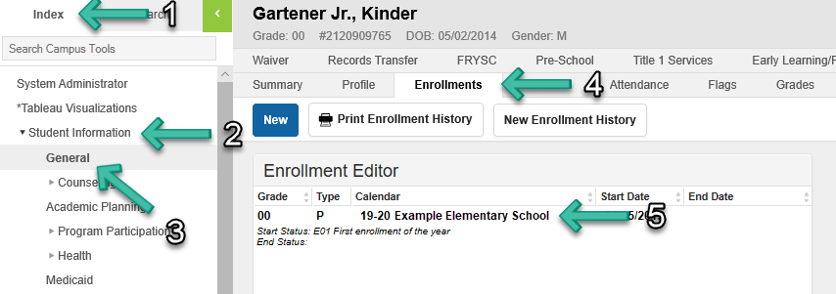

- Scroll down to the State Reporting Fields section [6] and verify the State Exclude checkbox [7] has not been marked.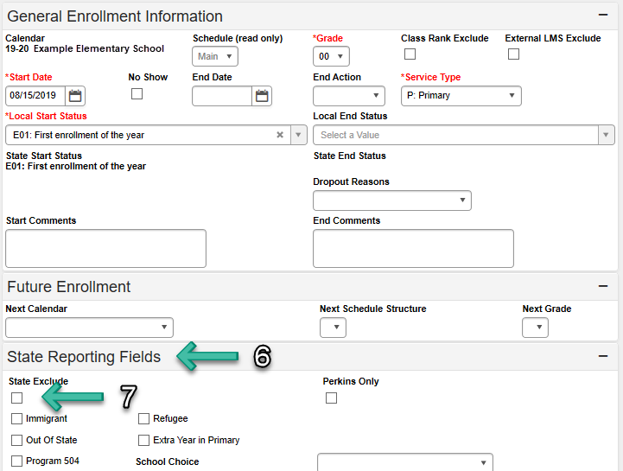

- Verify the kindergartener’s homeroom course has been assigned the correct State Code.

- With a kindergartener selected, from the Index [1] navigate to Student Information [2] and select General [3]. Click the Schedule tab [4] and find the appropriate homeroom course [5].

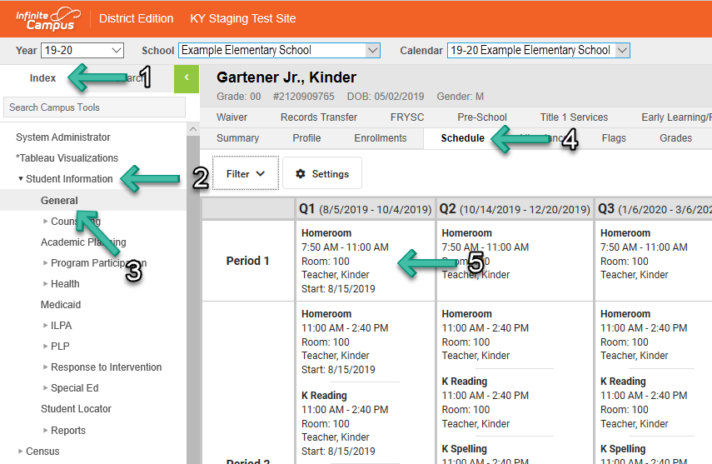

- Click Search [6], change the search dropdown menu to Course/Section [7], enter the name of the homeroom course, and click Go [8]. Select the main course entry for the homeroom course [9]. On the Course tab [10], verify 703001 has been entered into the State Code field [11].

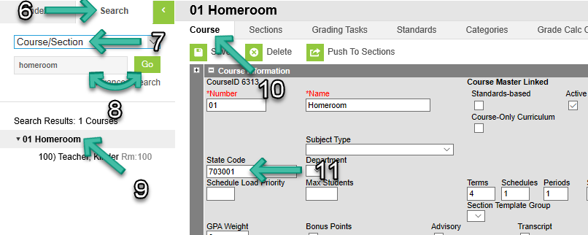

PLEASE NOTE: Ensure the kindergartener’s homeroom course is the only scheduled course which has been assigned to state code 703001.

- Ensure at least one kindergartener (state grade 00) has been assigned to each kindergarten homeroom course.

- Click Search [1], change the search dropdown menu to Course/Section [2], enter the name of the homeroom course, and click Go [3]. Select the appropriate homeroom section [4]. Click the Roster tab [5] and verify at least one kindergartener has been assigned to the course section [6].

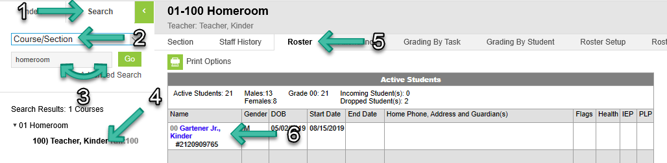
- Ensure all kindergarten homeroom teachers’ district-assigned email addresses have been properly entered.

- From the Index [1], navigate to Census [2] and select People [3]. On the Demographics tab [4], scroll down to the Personal Contact Information section [5] and verify the district-assigned email address has been entered into the Email field [6].
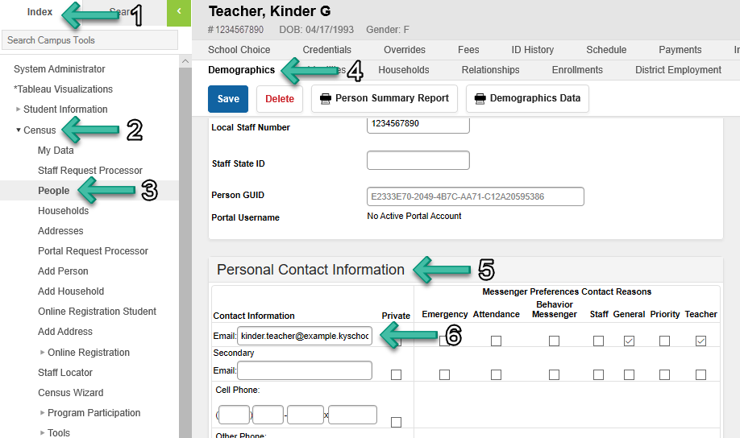

Appendix N – Contact Information
If You Have Questions/ Comments About: | Contact Information:
Kentucky Kindergarten Screen Implementation  - Timelines  - Deadlines  - Requirements  - Materials  - BRIGANCE OMS data entry requirements and timelines  - Infinite Campus questions | Lisa Jett  Office of Assessment and Accountability, KDE  lisa.jett@education.ky.gov  (502) 564-4394, ext. 4755
BRIGANCE K Screen  - Content  - Administration directions  - Scoring  - Interpreting results  - Guidance on using BRIGANCE OMS features such as Observations, Family Connections and reading/interpreting reports | Curriculum Associates  Customer Service  (800) 225-0248, option 4  info@cainc.com
BRIGANCE Early Childhood Online Management System  - Technical questions/issues | Grace McGrane  wsupport@cainc.com  (800) 225-0248, ext. 1391
District Kindergarten Screen Implementation  - Face-to-face training for K Screen implementation dates, times, etc. | BRIGANCE K Screen contact in your district

Appendix O – Quick Start Guides

The Quick Reference Guides are pieces of key information that will ensure a smooth K Screen implementation. Please provide them to the appropriate school personnel carrying out the roles needed to complete the K Screen process. These guides provide easy access to the information contained in this implementation guide in a condensed format. Please provide them to Data Entry Clerks, and Teachers administering the K Screen in their classroom.

Data Entry Quick Reference Guide
Screening Administration Quick Reference Guide

